**Neptune3 Firmware Update Guide**

* **Files description：**



Screen firmware



Motherboard firmware

* **Preparation：**

1. Format the TF card.

File system: FAT32 Allocation unit size: 4096 bit

1. Copy the two files into the root directory of the TF card.

* **Screen firmware update：**

1. As shown like pic 1, disassemble the back shell.
2. Pay attention to the plug location, insert the TF card.

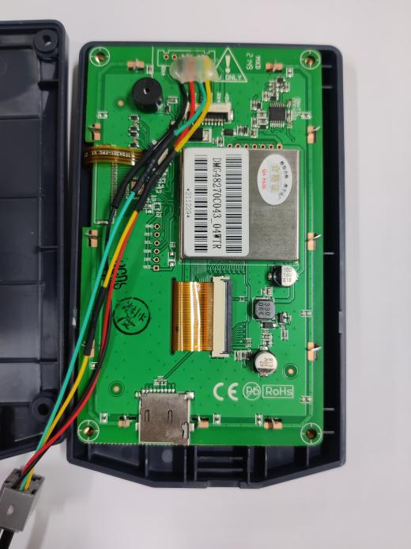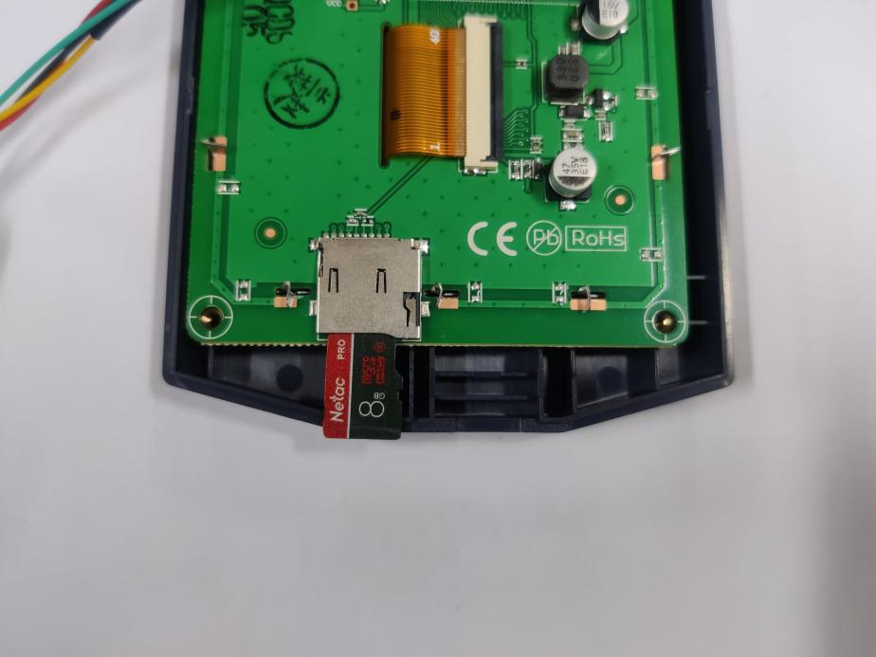

**Pic 2**

**Pic 1**

1. Reboot the power, wait until the firmware finish loading. The interface shows like below after the firmware loads.(Screen firmware update time: around 70s)

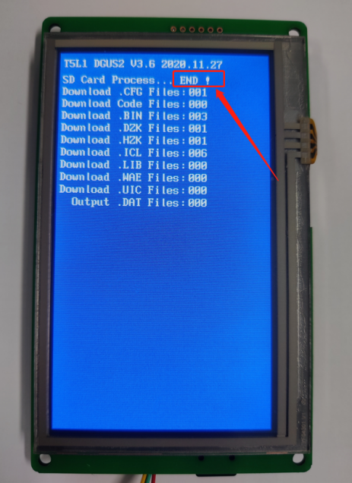

* **Motherboard firmware update：**

Insert the TF card into the machine. Reboot the power, wait until the firmware finish loading. The interface shows like pic3 when the firmware is loading. It will enter the interface like pic4 once the firmware is updated.

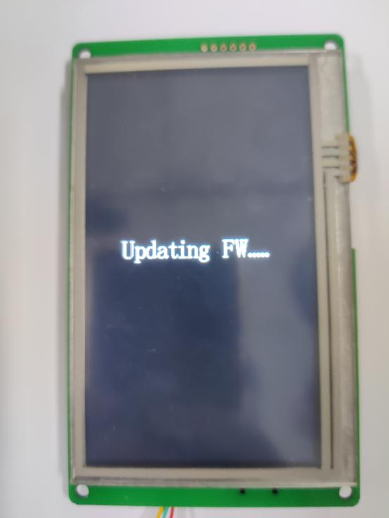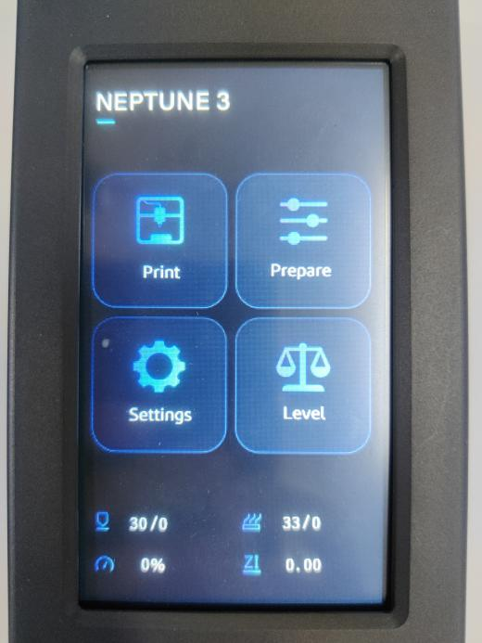

**Pic 4**

**Pic 3**

**Remind:**

If the leveling fails or the homing fails, please try to restart the power or choose to restore the factory settings in the settings.

The leveling grid data will be cleared after a factory reset and must be re-leveled.

**Leveling Temperature Recommendations:**

Hot end temperature: 0 ℃

(in order to avoid fan rotation and temperature affecting the leveling accuracy)

Hot bed temperature:

the temperature required by the filament +5 °C

(To avoid the leveling effect due to the thermal deformation of the hot bed)

#### Board firmware

Update log：

20220616：

- Added the setting item of leveling temperature. You can customize the leveling temperature in the Settings.

20220711:

- Improved leveling method.

20220816:

- Fixed some discovered bugs. Optimize the leveling speed and return to the origin speed.

- During the printing process, click 【Pause】 or "Break Detection" to detect a break in the filament, the extruder will pump back 6mm to avoid the filament leakage issue after the pause. At the same time, when you click 【Resume】 after the pause, the extruder will advance 6mm in the original printing position, so if you replace the filament, please do not insert it directly into the nozzle position.

- To solve the problem that the Z-offset adjusted during printing will not be saved：During printing, click 【stop】→【confirm】 or click 【confirm】 after printing is completed, the Z-offset value will be saved automatically.

Remind:

If the leveling fails or the homing fails, please try to restart the power or choose to restore the factory settings in the settings.

The leveling grid data will be cleared after a factory reset and must be re-leveled.

Leveling Temperature Recommendations:

Hot end temperature: 0 ℃ (in order to avoid fan rotation and temperature affecting the leveling accuracy)

Hot bed temperature: the temperature required by the filament +5 °C (to avoid the leveling effect due to the thermal deformation of the hot bed)

Reminder: At present, the Z-offset value set during printing will not be saved to EEPROM (Z-offset data will be lost after

power off or power failure, and Z-offset needs to be adjusted again when printing next time). Solution: You can save

the EEPROM by heading to 【Settings】 → 【Temperature】 → 【Leveling Temperature】, clicking 【Save】 in the upper

right corner of after printing is ‘completed or canceled’, so that the set Z-offset will be saved to the EEPROM.

#### Screen firmware

Update log：

20220711：

Added 【Leveling Temperature Settings】 to 【Settings】

20220816：

Added screen firmware version display.【Settings】→【About Machine】：

You can view the motherboard firmware version and screen firmware version.